**New Registration Flow**

1. Click “New Registration” button from “Home” Screen.

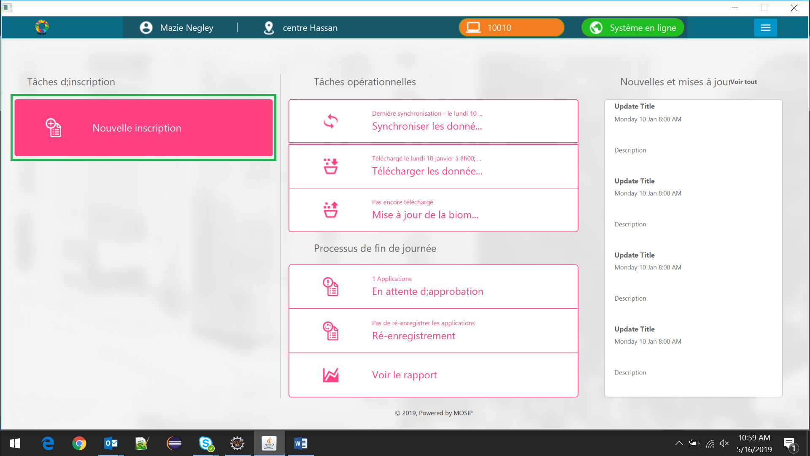

1. “Demographics Details” Section in “Registration” Screen will be displayed

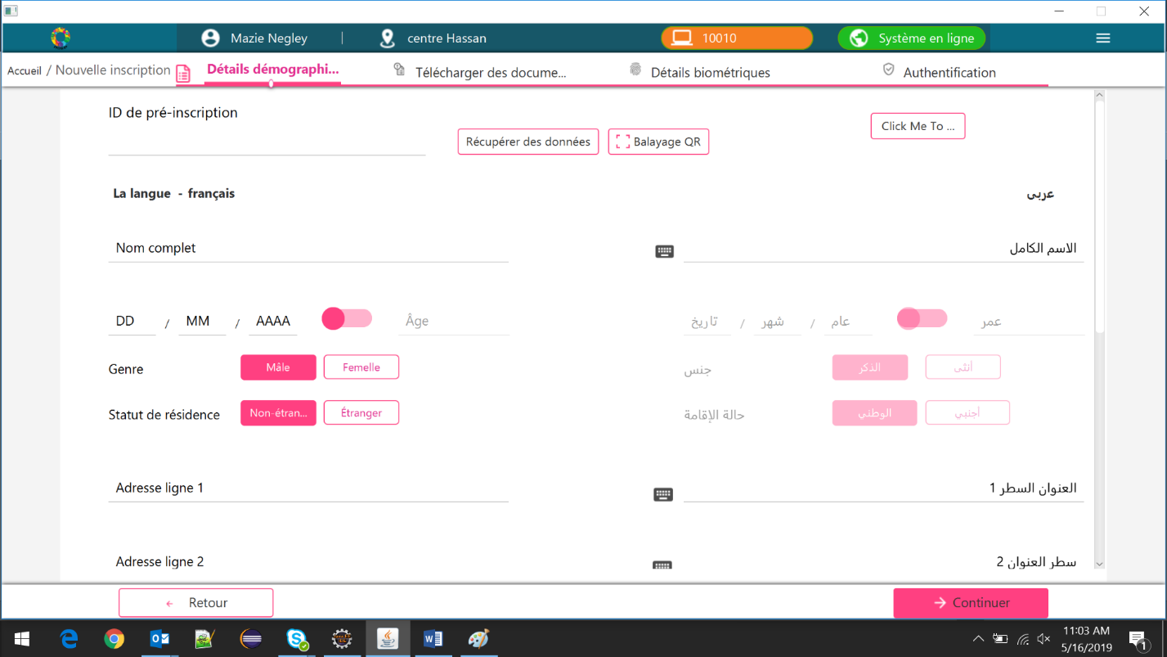

1. Provide the inputs for all the mandatory fields and click “Next”

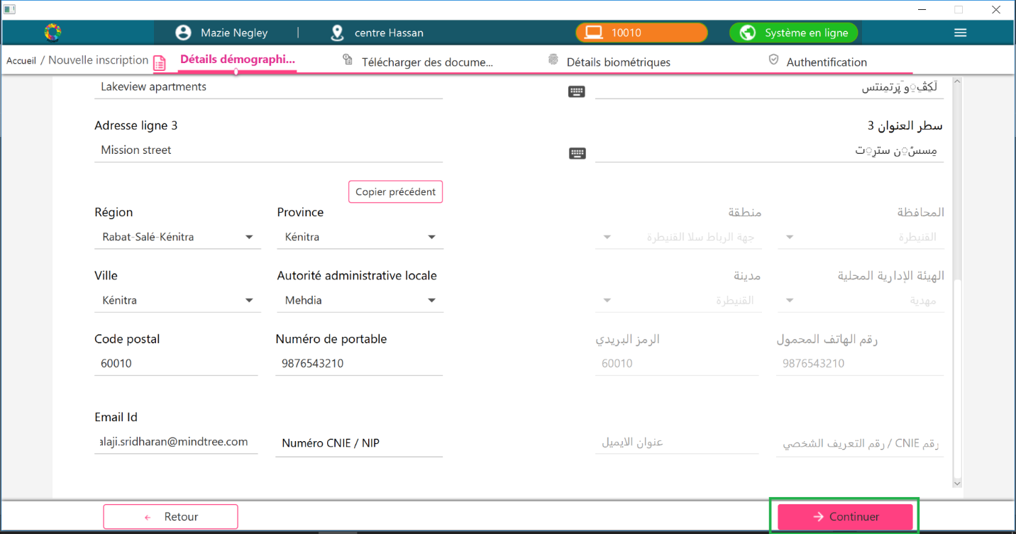

1. “Documents” Section will be displayed

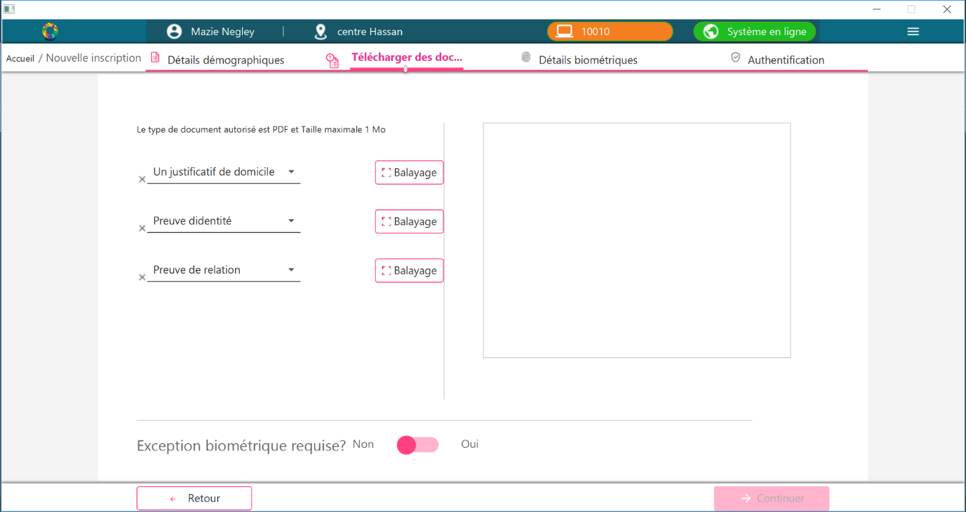

* 1. Steps to upload the documents

Select the “Document Type” from the drop-down

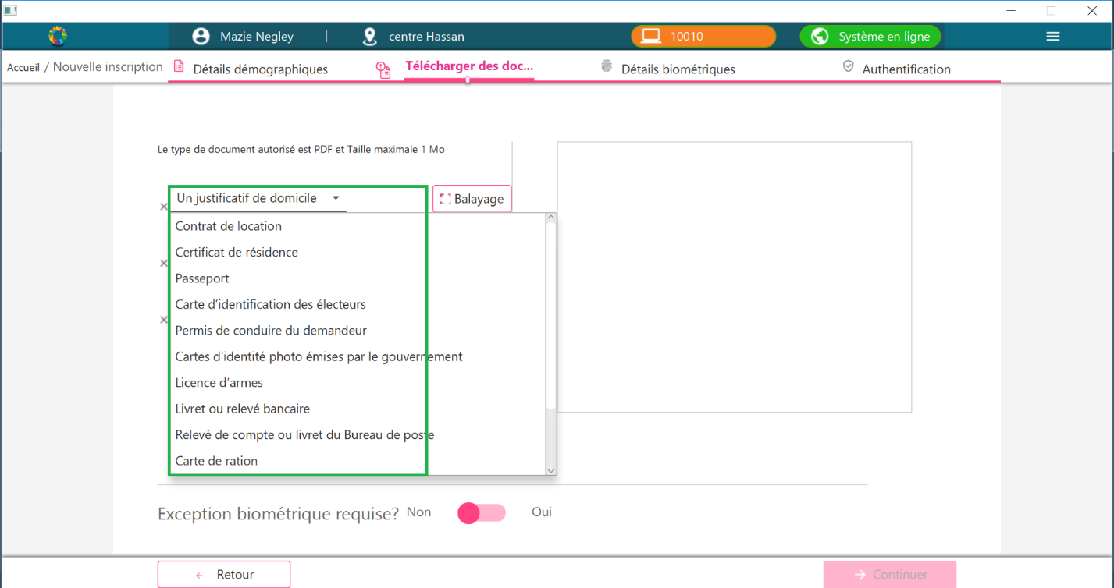

After selecting the “Document Type”, click “Scan” button

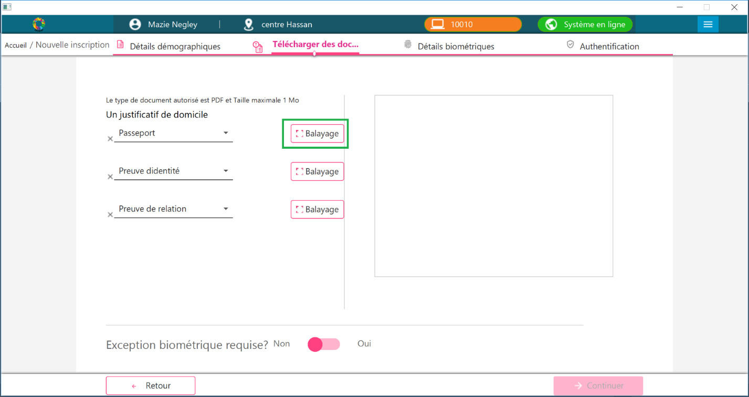

A pop-up screen would be displayed. Click “Scan” button from the pop-up

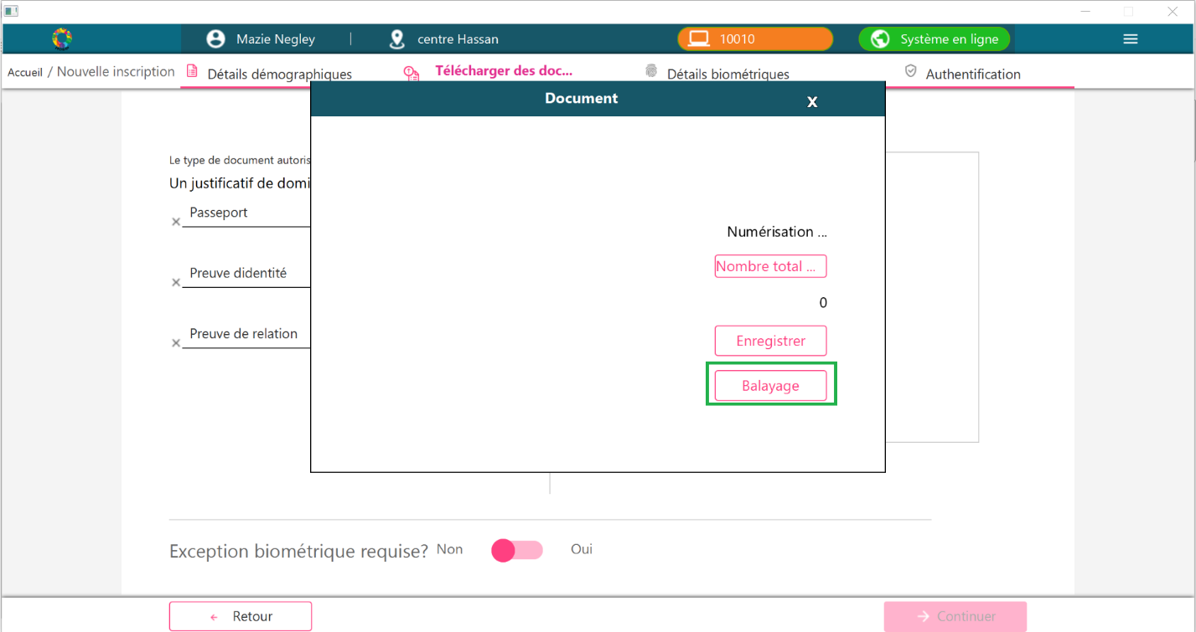

After scanning the document, a pop-up will be displayed. Click “ok” button. 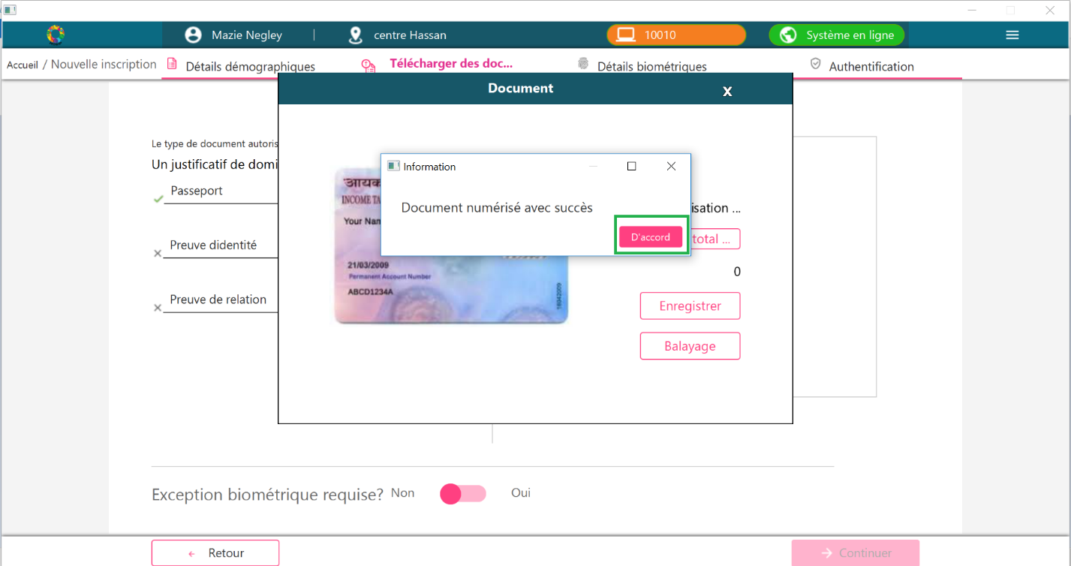

Repeat the above steps for uploading other documents.

1. To mark exception biometrics. Select “Yes” option

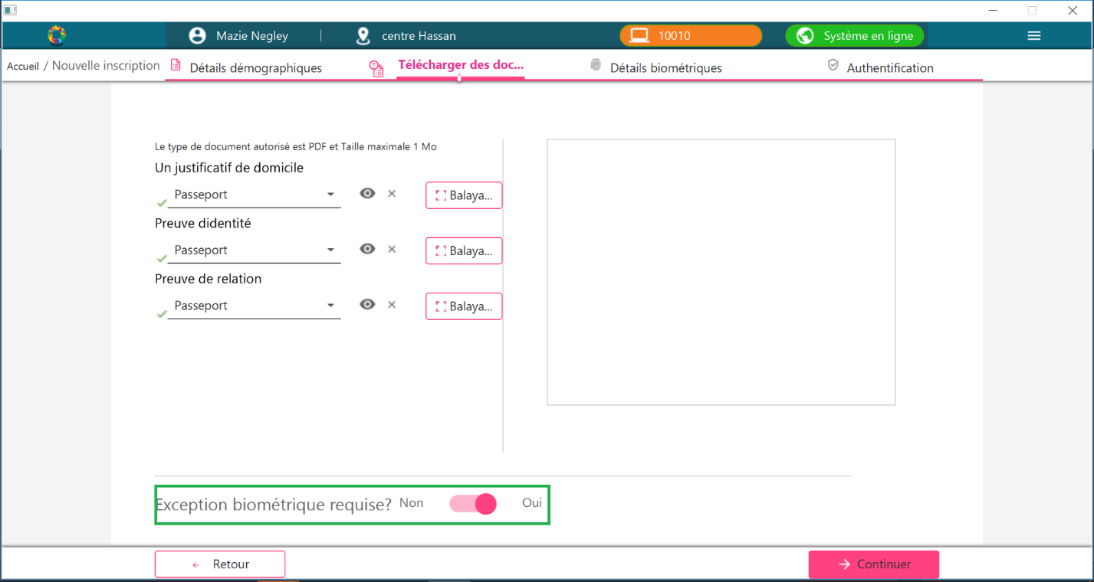

1. Click “Continue” button

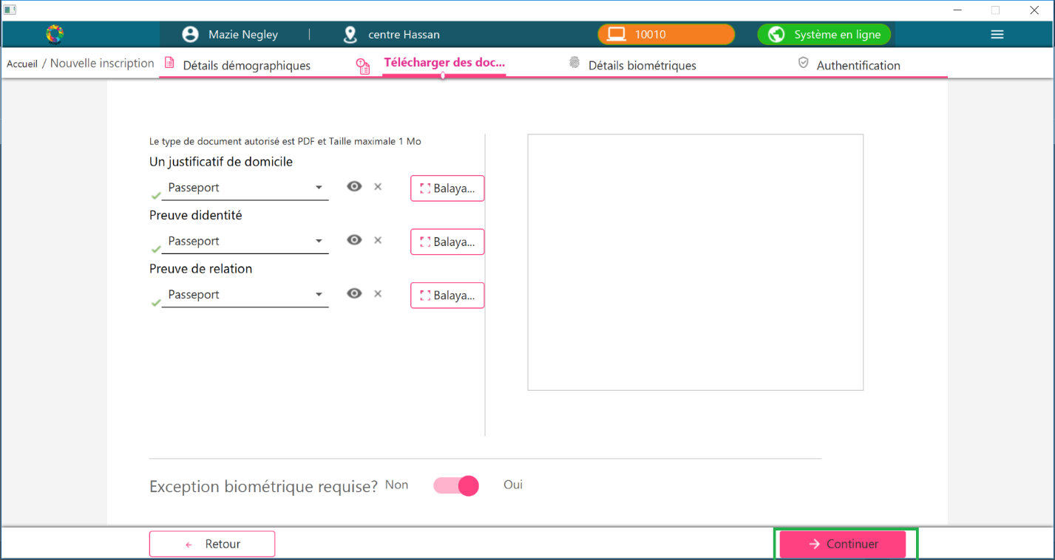

1. Biometrics Exception screen will be displayed

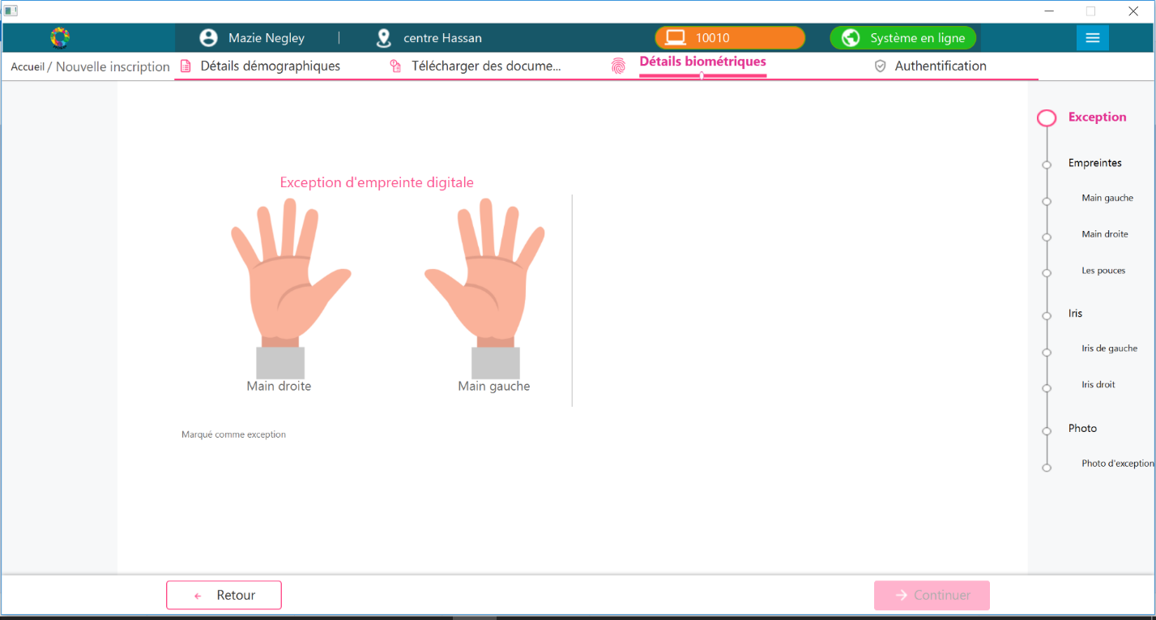

1. Mark the biometric exceptions

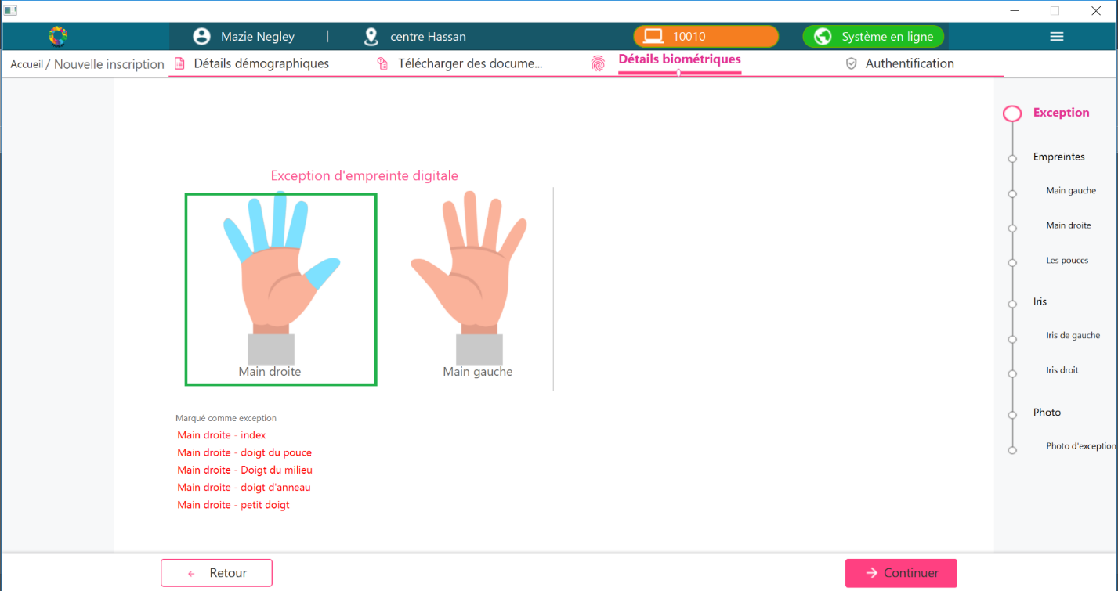

1. Click “Continue” button

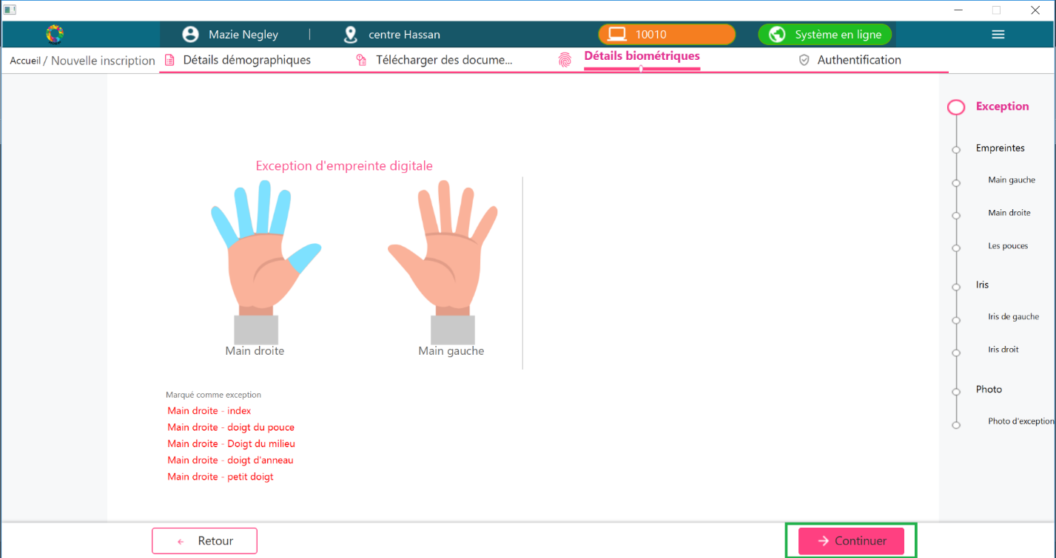

1. Fingerprints capture screen will be displayed

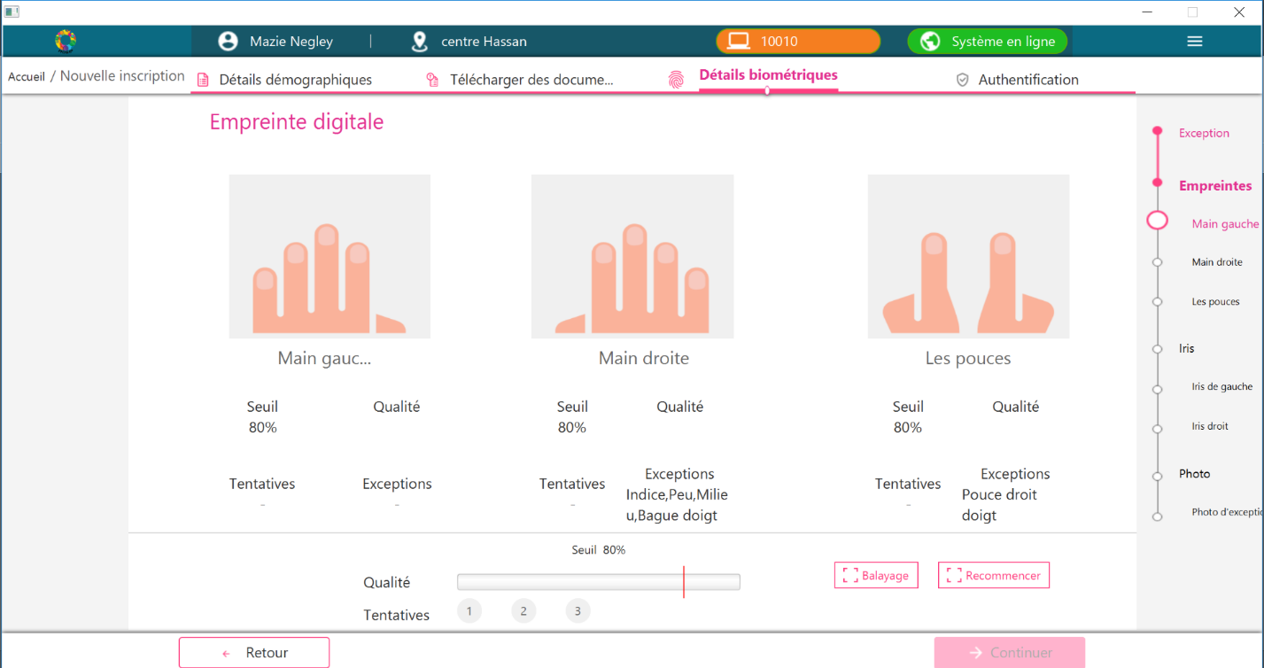

1. Select the slap and click “Scan”

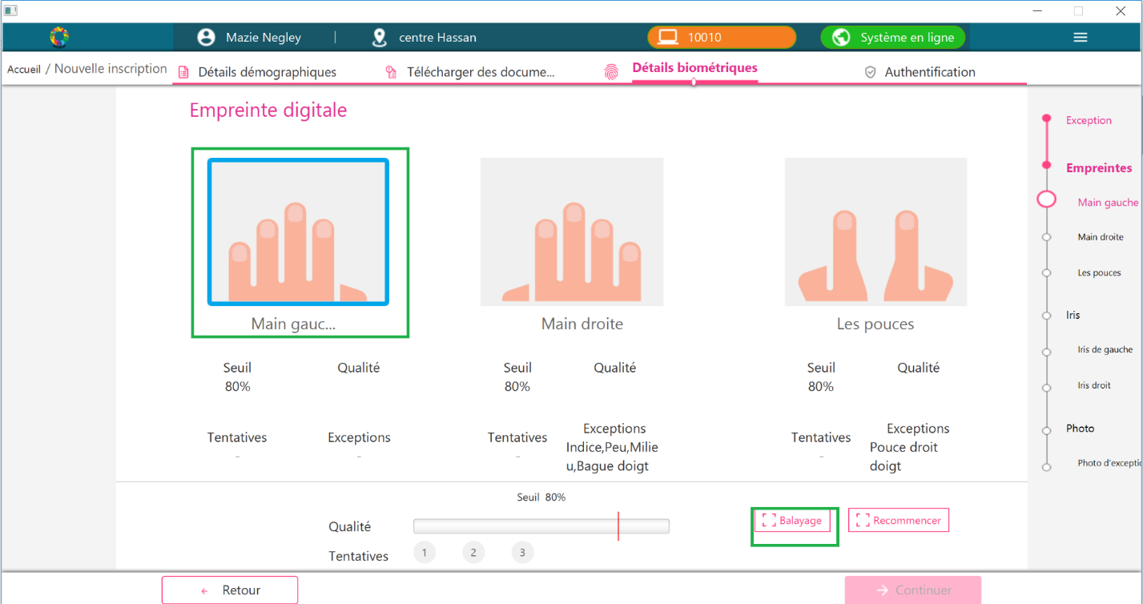

1. A pop-up screen will be displayed. Click Scan button from the pop-up screen

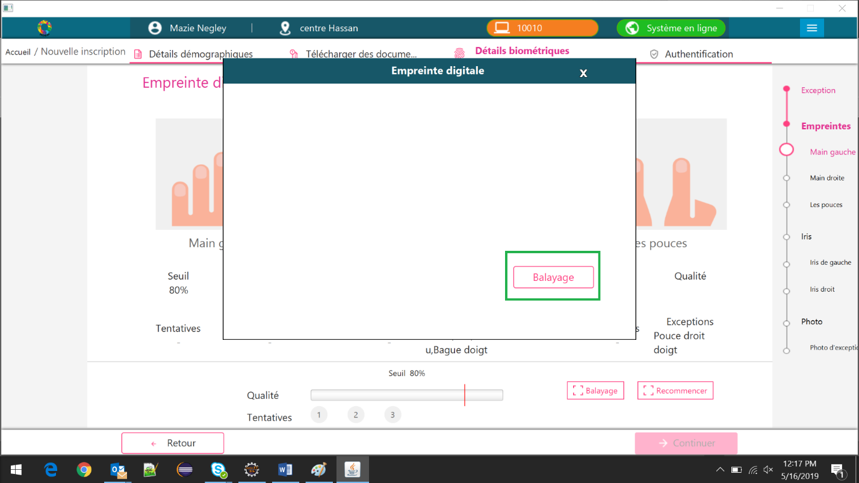

1. After scanning the slap, click “Ok” from the confirmation pop-up

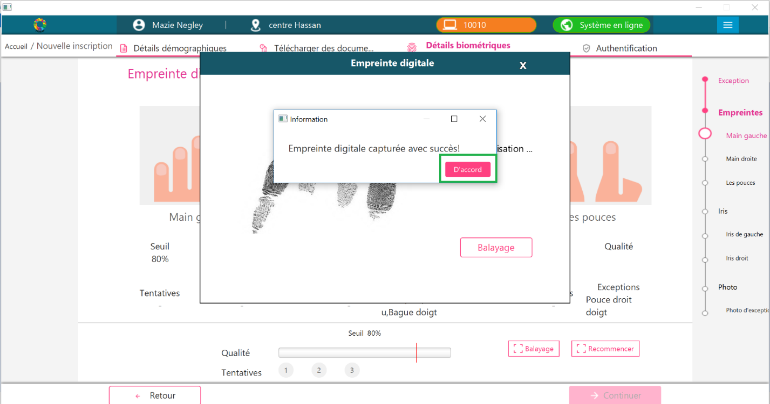

1. Repeat the above steps to scan the other slaps and iris.
2. Photo capture screen will be displayed

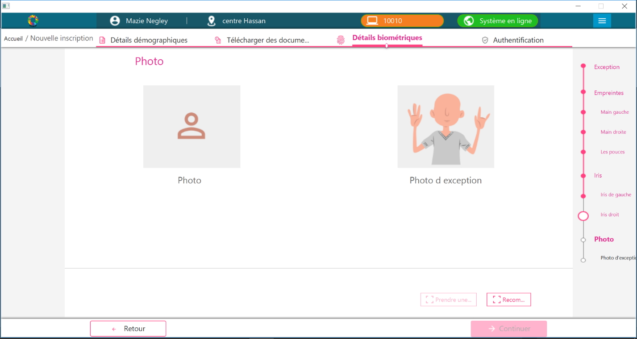

1. Select the Photo and click “Photo capture” button

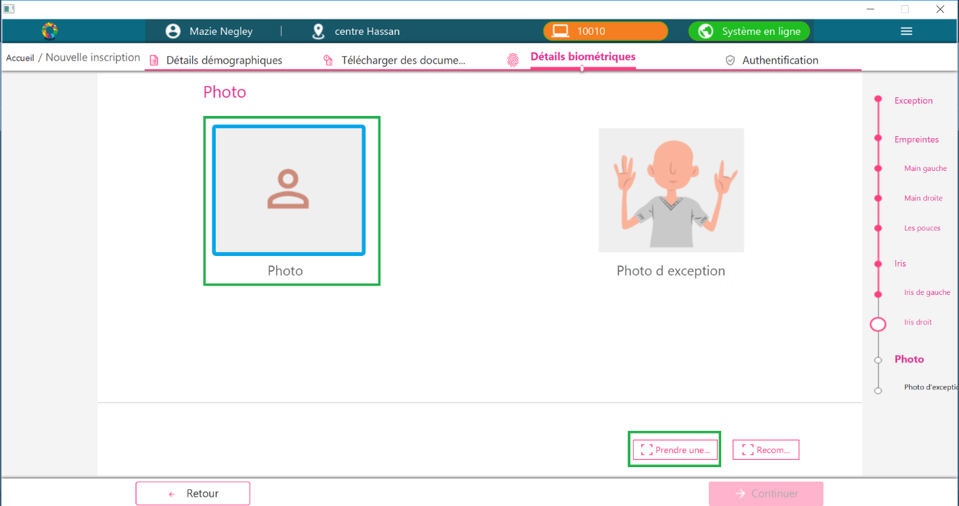

1. Photo capture pop-up screen will be displayed. Click Capture button from the pop-up screen

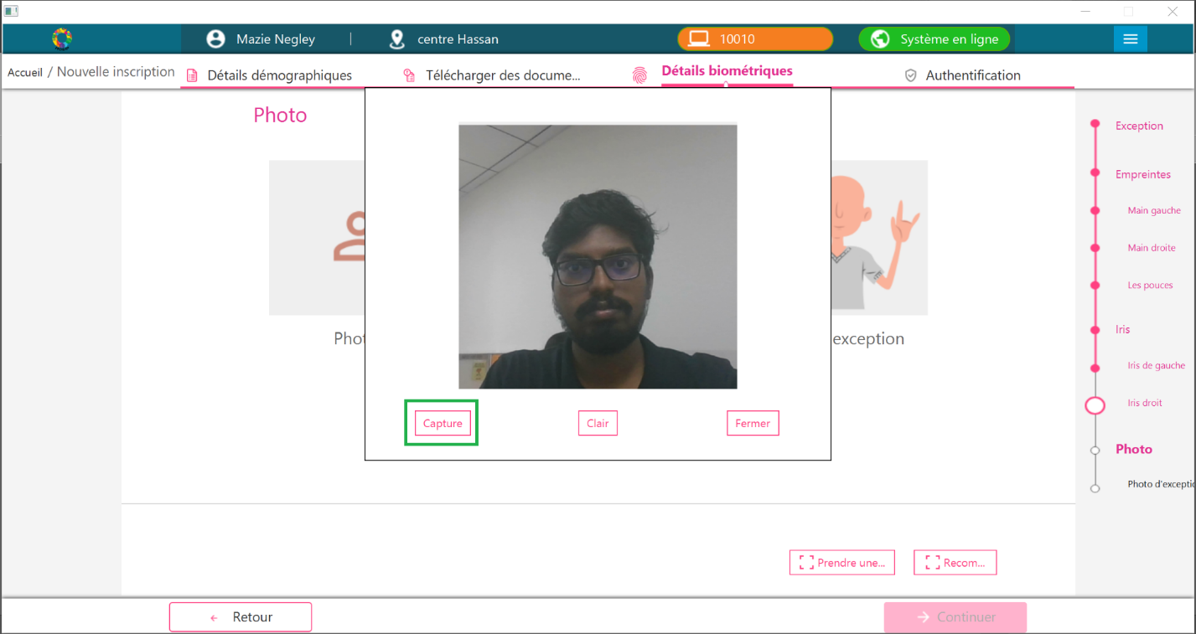

1. Click Close button from the pop-up screen

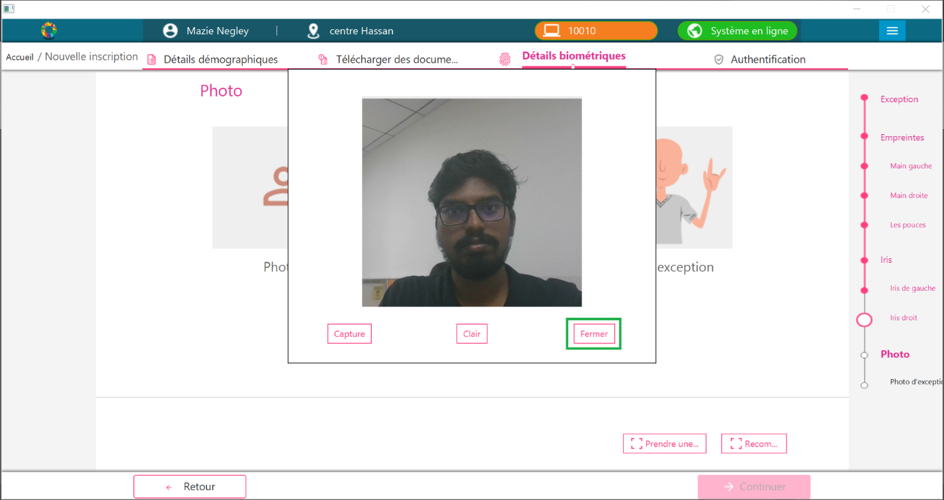

1. Capture the exception photo if required. Then click the Continue button.

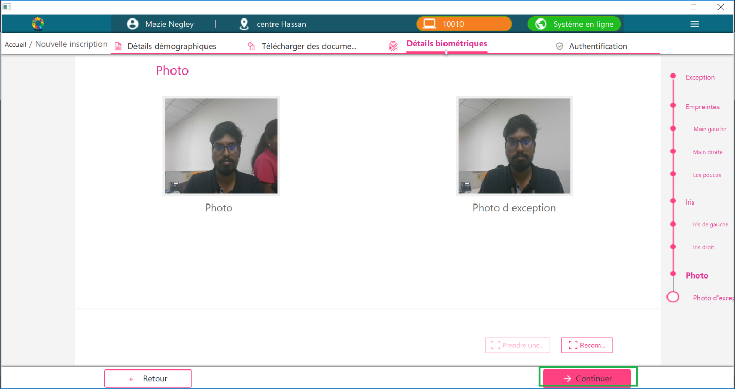

1. Preview screen will be displayed. To modify any details, click “Modify” button against the respective section.

Give the individual consent. And click “Continue”

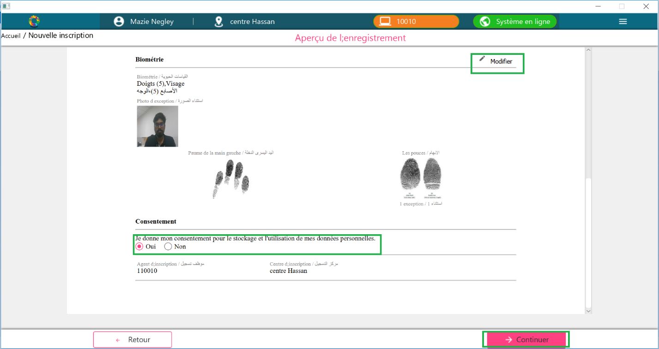

1. Packet authentication will be followed after preview. Upon successful authentication, Acknowledgement Receipt will be displayed.